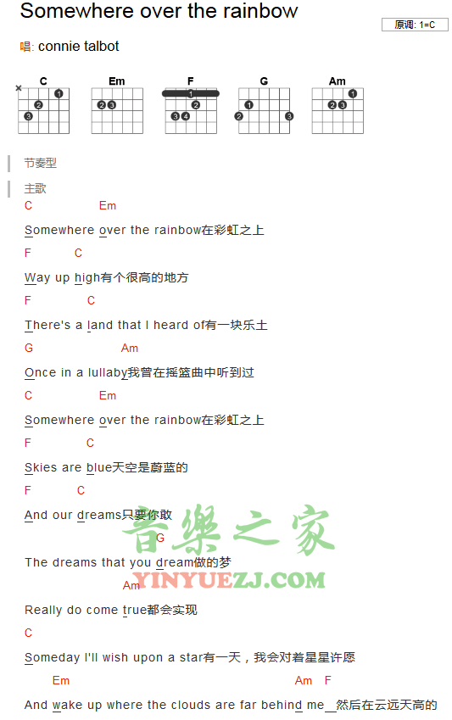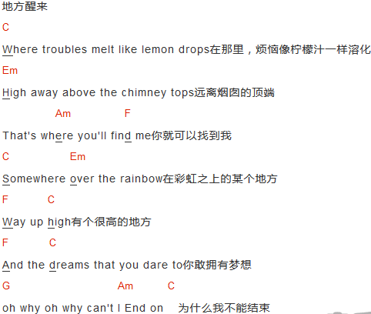

Over The Rainbow  
Somewhere over the rainbow Way up high  
There's a land that I heard of once in a lullaby  
Somewhere over the rainbow Skies are blue  
And the dreams that you dare to dream really do come true  
Someday I'll wish upon a star  
And wake up where the clouds are far behind me  
Where troubles smelled like lemon drops  
Away above the chimney tops That's where you'll find me  
Someday I'll wish upon a star  
And wake up where the clouds are far behind me  
Where troubles smelled like lemon drops  
Away above the chimney tops That's where you'll find me  
Somewhere over the rainbow Skies are blue  
And the dreams that you dare to dream really do come true  
If happy little bluebirds fly  
Beyond the rainbow Why, oh why, can't I?